INFOSYS SPRINGBOARD 6.0

Name- Swapnil Pal
Topic- Smart Energy Consumption Analysis and Prediction using Machine Learning with Device-Level Insights
Documentation for Week 1

Smart Home Energy Consumption
Data Preprocessing, Visualization & Machine Learning Documentation

1. Project Objective
The objective of this project is to analyse and predict smart home energy consumption using historical data. The project focuses on understanding how factors such as appliance type, time, season, temperature, and household size affect energy usage, and to prepare the data for machine learning models.

2. Dataset Description
The dataset contains smart home energy usage records with the following attributes:
- Home ID
- Appliance Type
- Energy Consumption (kWh)
- Time
- Date
- Outdoor Temperature (°C)
- Season
- Household Size
The dataset consists of 100,000 records and is suitable for exploratory data analysis and machine learning.

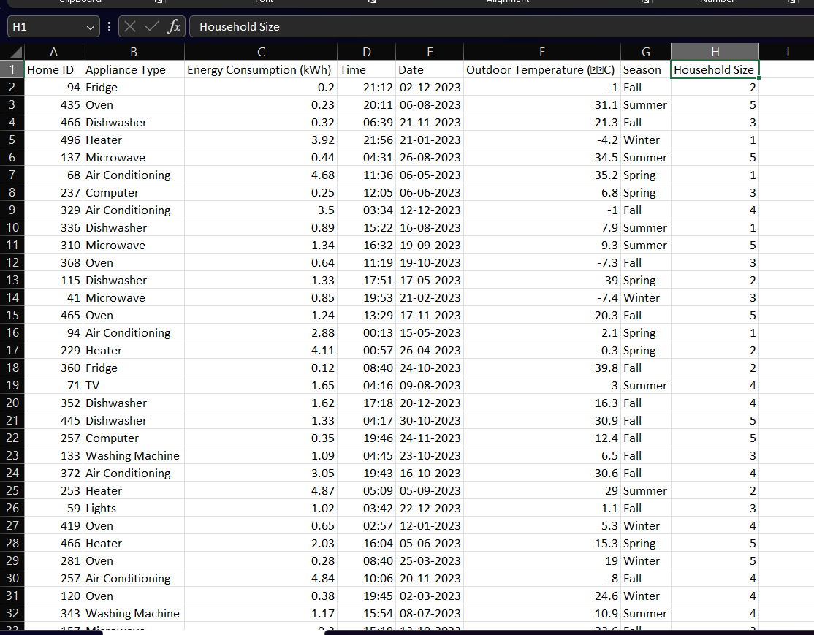

3. Data Loading and Initial Inspection
The dataset is loaded using Pandas. Initial inspection is performed using:
- head() to view sample rows
- shape to check dataset size
- columns to identify features
- describe() for basic statistics
This step helps understand the structure and scale of the data.
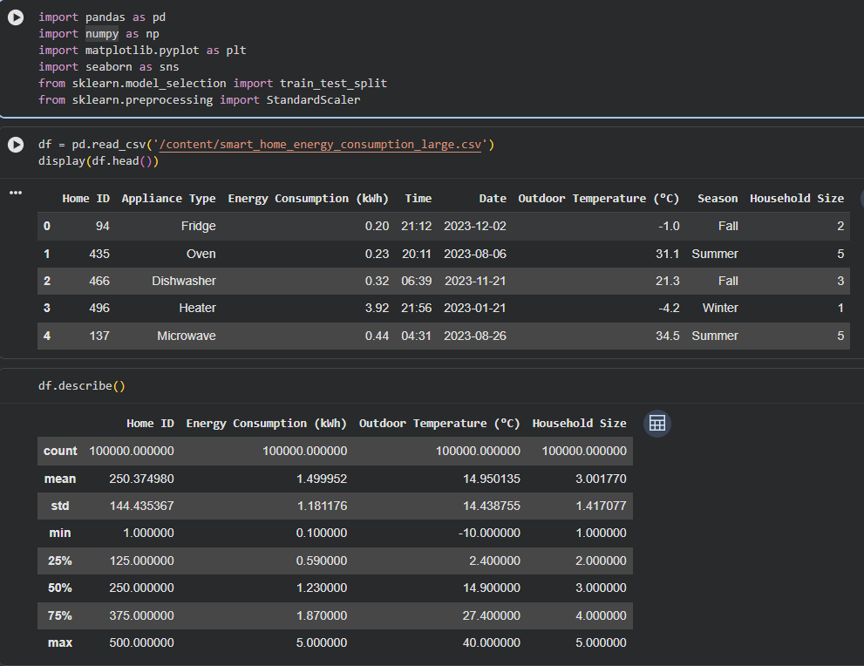

4. Date and Time Processing
4.1 Date Conversion
The Date column is converted into a datetime format to allow time-based analysis.
4.2 Hour Extraction
The Time column is converted into an Hour feature (0–23), as energy consumption strongly depends on the time of day.
Purpose:
To enable hourly energy usage analysis and improve feature quality for ML models.

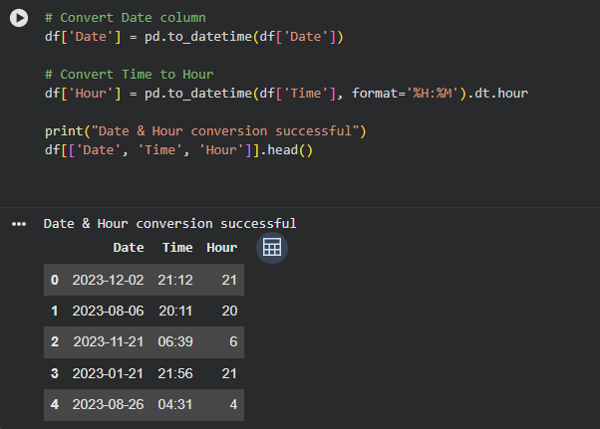

5. Data Validation
Data types are verified to ensure correct conversions.
Missing values are checked to confirm data integrity.
Result:
No missing values were found, indicating a clean dataset.

6. Timestamp Creation
A combined Timestamp column is created using Date and Time.
Purpose:
- Enables chronological sorting
- Required for time-series features like lag and rolling averages

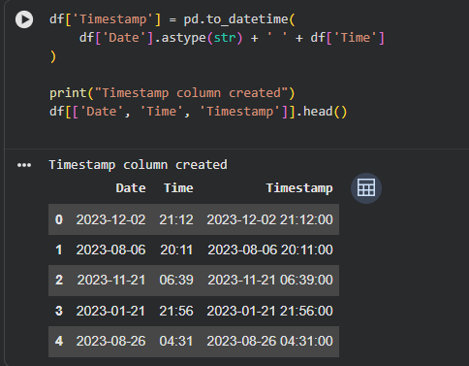

7. Data Sorting
The dataset is sorted by Home ID and Timestamp.

8. Outlier Detection and Removal
Method Used: Interquartile Range (IQR)
Outliers are identified using:
- Q1 (25th percentile)
- Q3 (75th percentile)
- IQR = Q3 − Q1
Values outside Q1 − 1.5 × IQR and Q3 + 1.5 × IQR are removed.
Result:
- Outliers removed: ~1,900 records
- Data becomes more realistic and stable
Purpose:
- Prevents extreme values from misleading ML models
- Improves visualization clarity and prediction accuracy
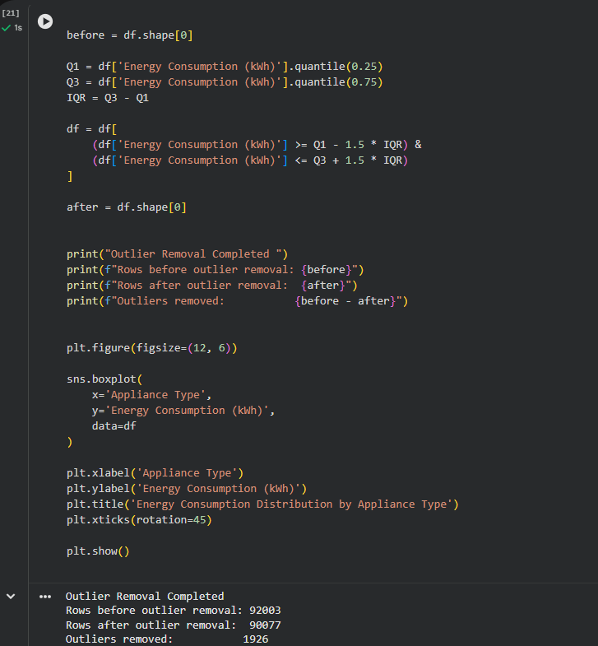

9. Feature Scaling (Standardization)

Energy consumption values are scaled using StandardScaler.
What scaling does:
- Converts values to a standard scale
- Mean becomes ~0
- Standard deviation becomes ~1
Why scaling is needed:
- ML models perform better when features are on similar scales
- Prevents large values from dominating learning
Scaled values indicate how far a value is from the average in terms of standard deviation.

10. Time-Based Feature Engineering
Additional time features are extracted:
- Day
- Month
- Weekday
Purpose:
Energy consumption varies by:
- Day of month
- Season
- Weekdays vs weekends
These features help the model learn behavioural and seasonal patterns.

11. Exploratory Visualization (Boxplot)
A boxplot is used to visualize energy consumption by appliance type.
Insights:
- Heaters and air conditioners consume the most energy
- Refrigerators consume the least but consistently
- Boxplots clearly show variability and median usage
Purpose:
- Identify energy-intensive appliances
- Support smart energy optimization decisions
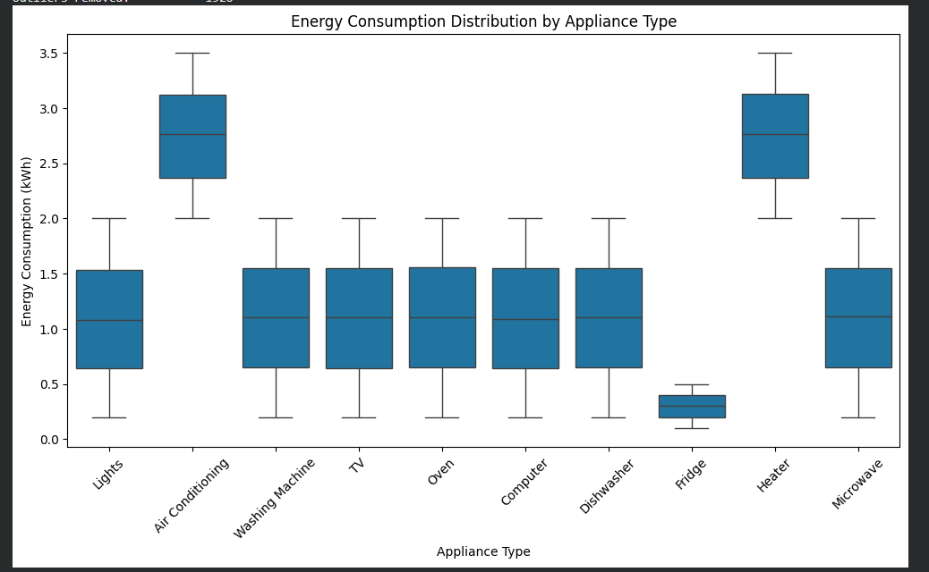

12. Categorical Encoding
Categorical features (Appliance Type, Season) are converted into numerical form using one-hot encoding.
Why encoding is required:
Machine learning models cannot process text values.
Why drop_first=True:
- Prevents dummy variable trap
- Reduces redundancy
- Improves model stability

13. Removing Redundant Columns
Columns such as Time and Timestamp are removed.
Reason:
- Information is already captured through engineered features
- Avoids redundancy and noise

14. Feature–Target Separation
The dataset is split into:
- X (features) – input variables
- y (target) – energy consumption
The target column is removed from X to prevent data leakage.
Purpose:
Ensures the model learns patterns instead of memorizing answers.

15. Train–Validation–Test Split
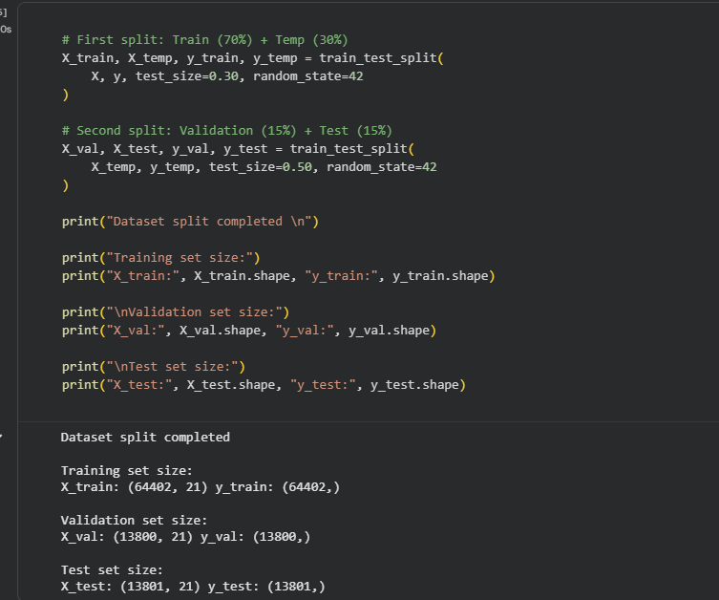
The dataset is split into:
- 70% Training
- 15% Validation
- 15% Testing
Why this split is used:
- Training set → learn patterns
- Validation set → tune model
- Test set → unbiased performance evaluation
A fixed random state ensures reproducibility.

16. Final Outcome
At the end of this pipeline:
- The dataset is clean
- Features are meaningful and numeric
- Data is ML-ready
- The project follows industry-standard practices

17. Conclusion
This systematic preprocessing and feature engineering approach ensures accurate, reliable, and unbiased prediction of smart home energy consumption. The prepared dataset can now be used effectively for machine learning models such as Linear Regression and Random Forest.

